**Chapter 7: Project Results**

The results from this project may be divided into three main categories: results from software implementation, results from hardware implementation, and the final version of the designed and manufactured UAV.

**A. Software**

In terms of software, two programs were used: MATLAB/Simulink and Mission Planner.

**MATLAB/Simulink implementation**

MATLAB/Simulink was used for the design of the UAV’s control system. Various Simulink models were created or adjusted from previous references to evaluate our quadrotor system and its initial parameters as shown in the System Specifications section. The implemented models had Simulink PID blocks for roll, pitch, yaw and altitude control. Then, the control system outputs were mapped into desired motor speeds according to the appropriate translation and rotation equations of motions.

From the evaluation models, a Simulink model containing the desired PID parameters to be uploaded to the Cube flight controller was devised as shown in Figure 7A.1. However, the upload was unsuccessful due to the fact that there were some communication conflicts in the buses which impaired the code upload process shown in Figure 7A.2. Thus, the team opted to adjust the control system from the Mission Planner ground control station.

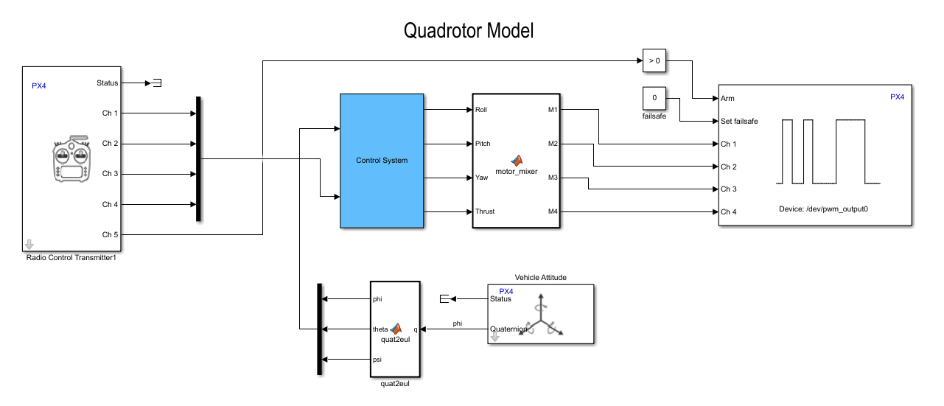

Figure 7A.1: Simulink model for Pixhawk 2

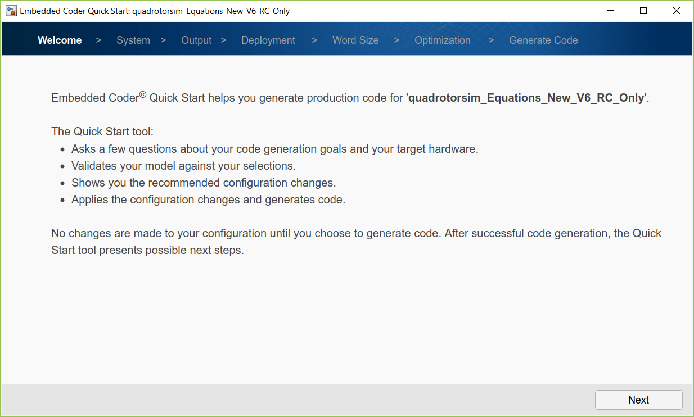

Figure 7A.2: Generating code for Pixhawk 2 from Simulink model

**PID parameters in Mission Planner**

As previously mentioned, due to the fact that the code from the Simulink model could not be uploaded to the Pixhawk flight controller, the UAV’s PID gains were successfully adjusted through the implementation of Mission Planner and its Extended Tuning section as shown in Figure 7A.3. As a result, successful flight was achieved.

Figure 7A.3: Mission Planner Extended Tuning window

**B. Hardware**

In terms of hardware, the quality of the designed was revised. First the rigidness of the arms shown in Figure 7B.1 was observed. During initial fly tests the arms started to bend upward due to the force created by the rotation of the propellers. It was concluded that the Nylon G material used for the printing was not strong enough. Therefore, all the arms were re-printed with PLA, a stronger material thus providing a better rigid body.

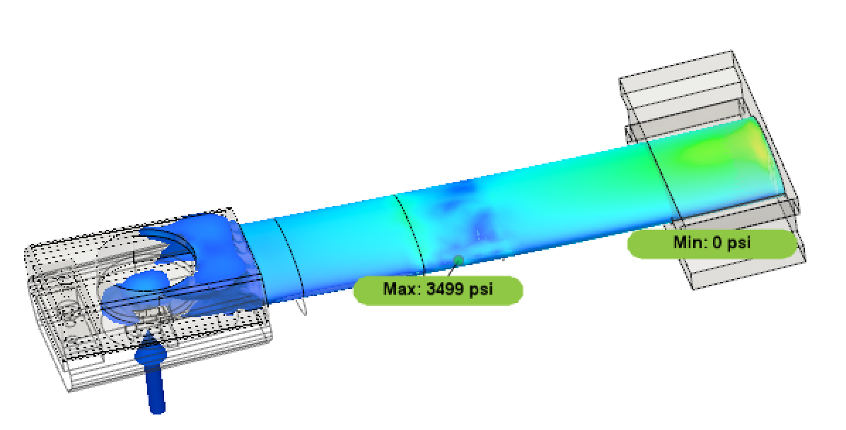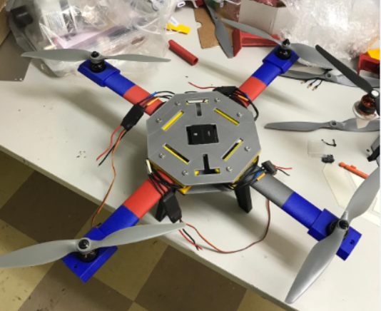

Figure 7B.1: Quadcopter arm

From another point of view, the UAV’s propellers guards resulted in need of redesign as well due to their tendency to impact the propeller during flight which caused flight instability. Two versions of the propeller guards were printed as shown in Figure 7B.2. The printing for version#1 took more than 5 hours to finish. Then, to significantly reduce printing time, version #2 was designed to consist of two separated pieces (“trident” and arch) that were glued together. The material used was the same as the arms to obtain more rigidness. However, while in flight the arch of the propeller guard got loose which caused an impact to the propeller and made the quadcopter fall as shown in Figure 7B.3.

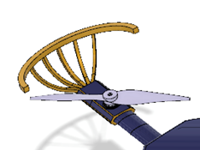 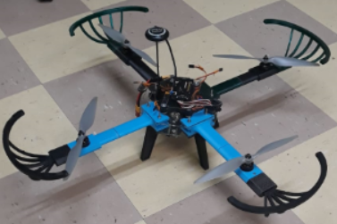 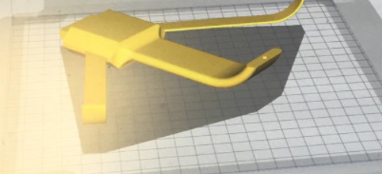 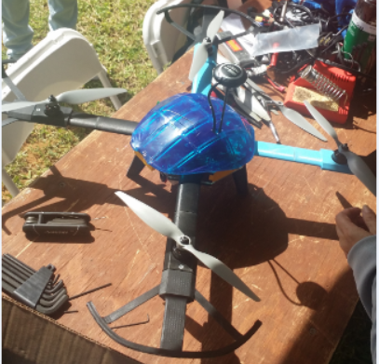

(a) (b)

Figure 7B.2: Propeller guard (a) version#1 (b) version#2

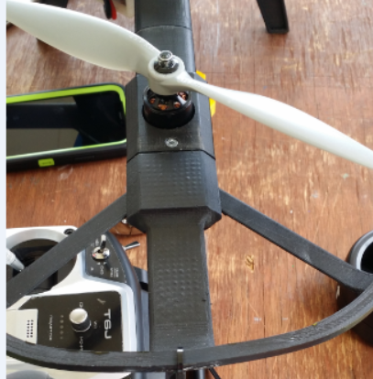 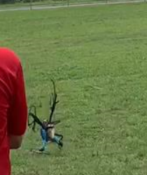 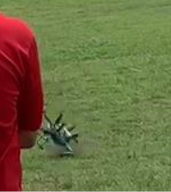

Figure 7B.5: Quadcopter crash due to faulty propeller guard

Another part of the quadcopter that needed to be re-printed was the top and bottom bases shown in Figure 7B.6. The material used was Lexan and during tests, this material was observed to shatter easily.

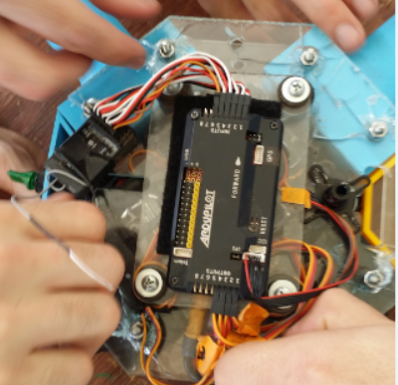 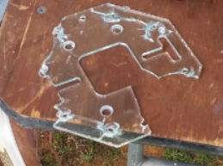

Figure 7B.6: Quadcopter top/bottom bases shattered

**C. Final Design**

After mentioning the results from software and hardware implementation, the following figure (Figure 7C.1) may be shown to represent the final version of the designed and manufactured UAV.

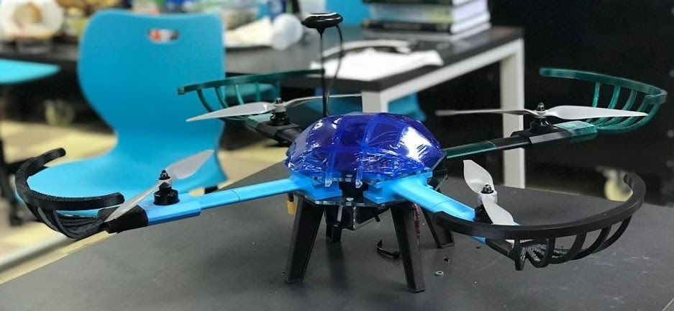

Figure 7C.1: Designed and manufactured UAV (final version)